

**NAME : FAIZAN MANZAR**

**ROLL NO : F2022266260**

**SECTION : V3**

**COURSE NAME : WEB TECHNOLOGIES**

**COURSE INSTRUCTOR : NOAMAN SALEEM**

**ASSIGNMENT 3**

**Repository Link :**

[**https://github.com/faizanjutt0147/web-assignment-3?tab=readme-ov-file**](https://github.com/faizanjutt0147/web-assignment-3?tab=readme-ov-file)

**HTML Code :**

* **Index.html :**

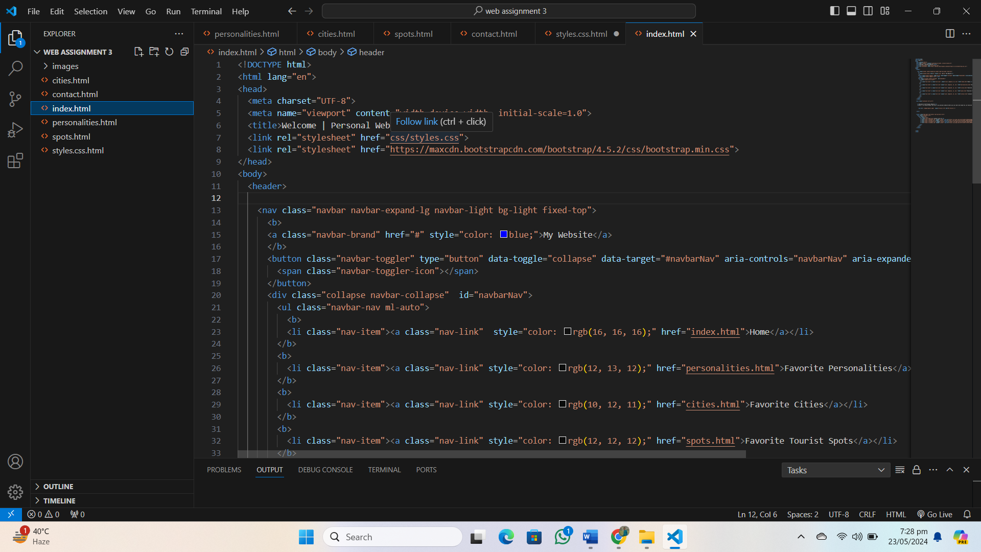

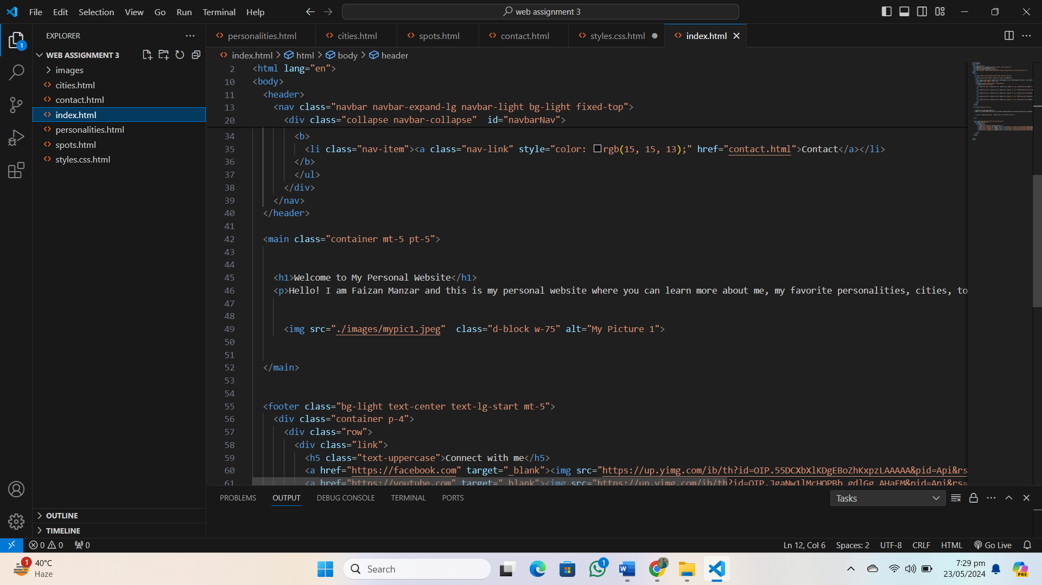

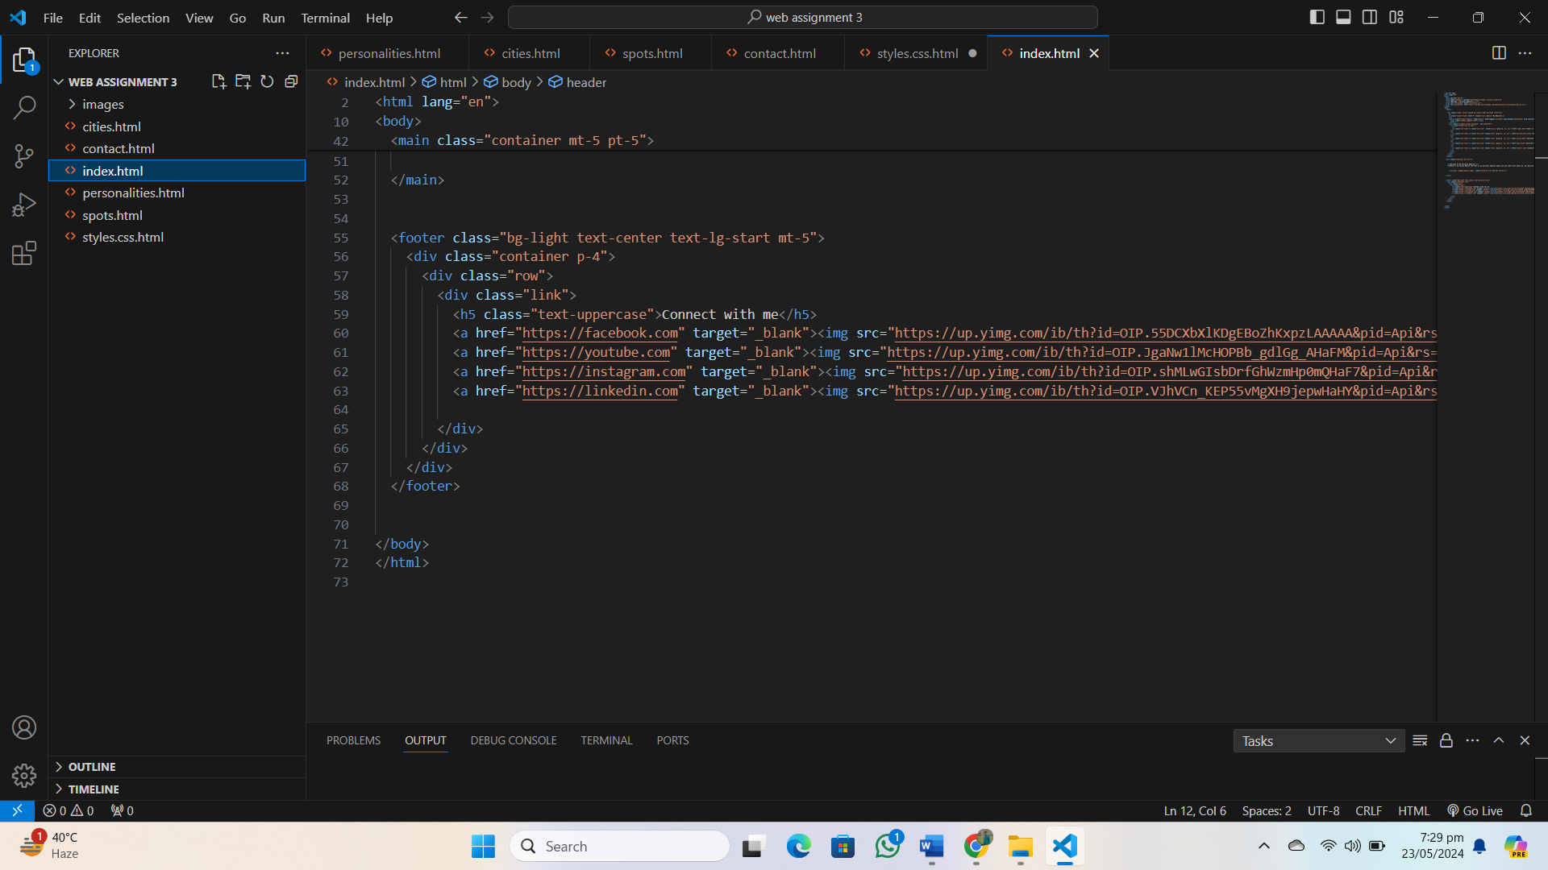

* **Cities.html :**

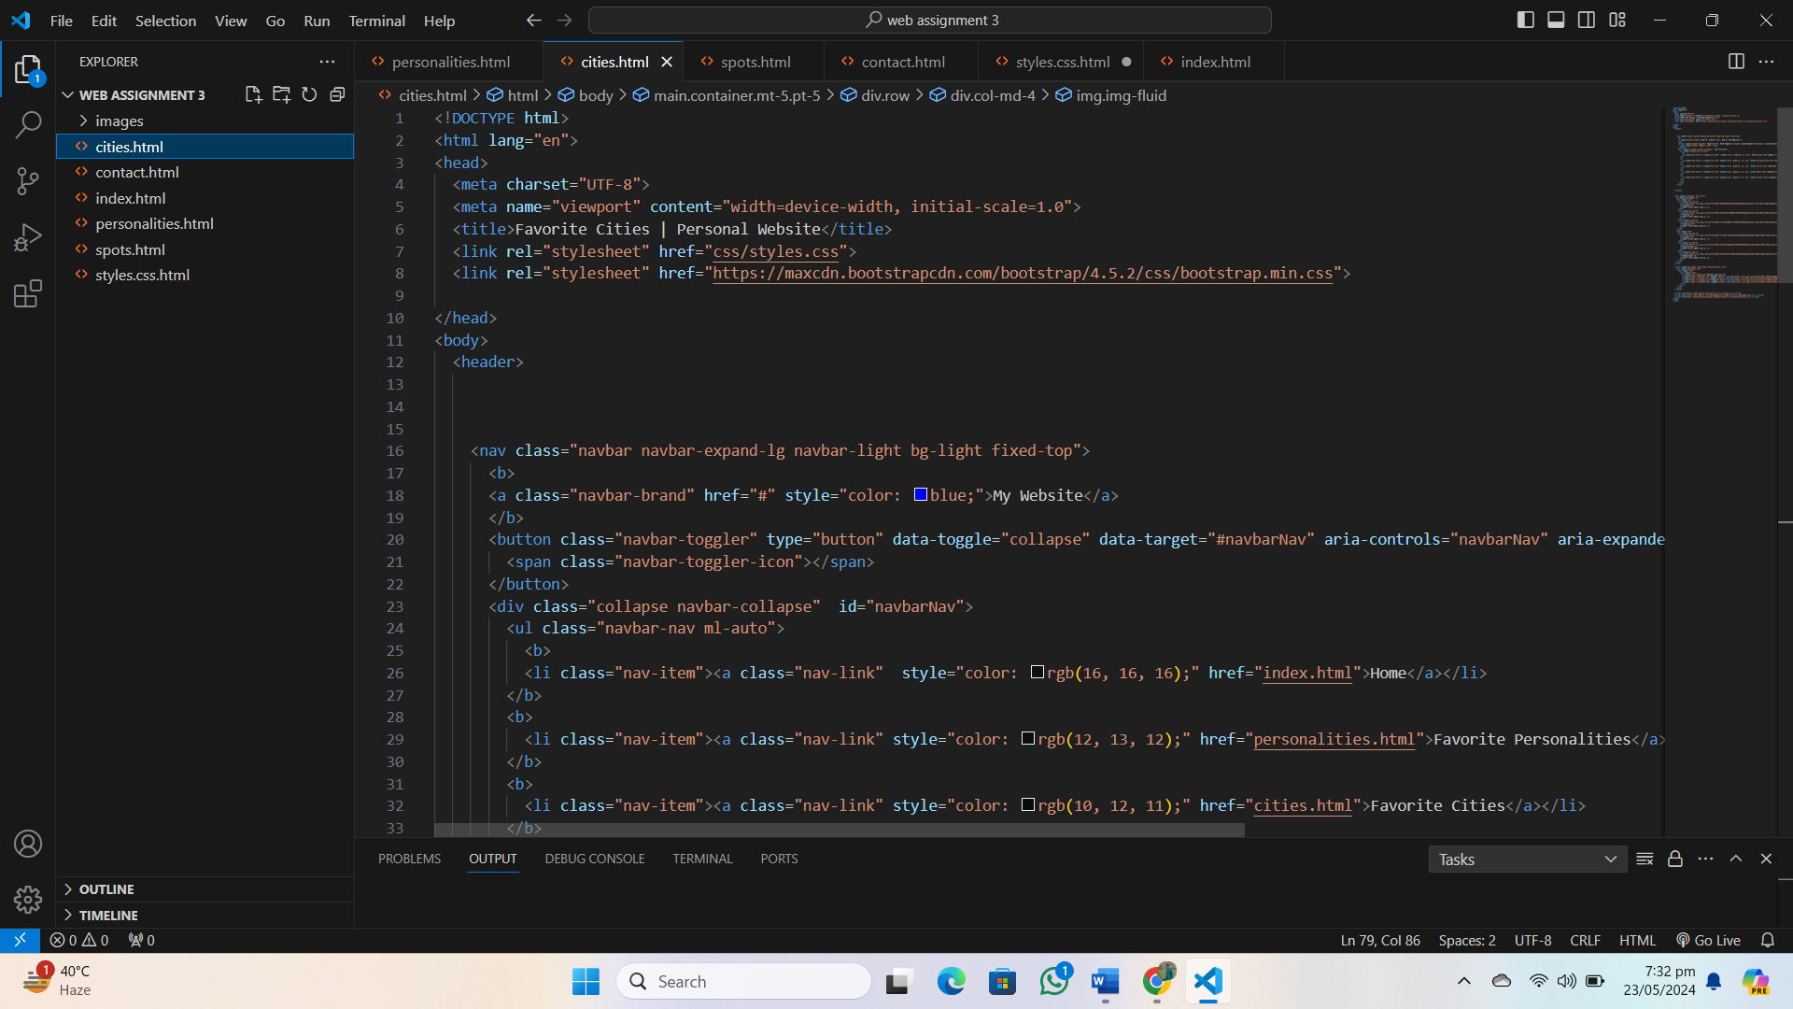

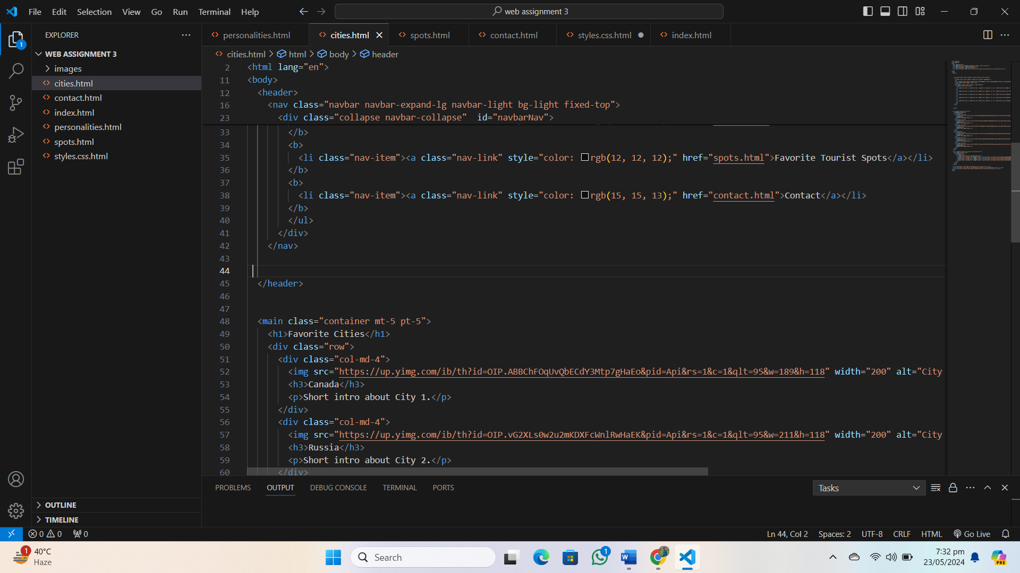

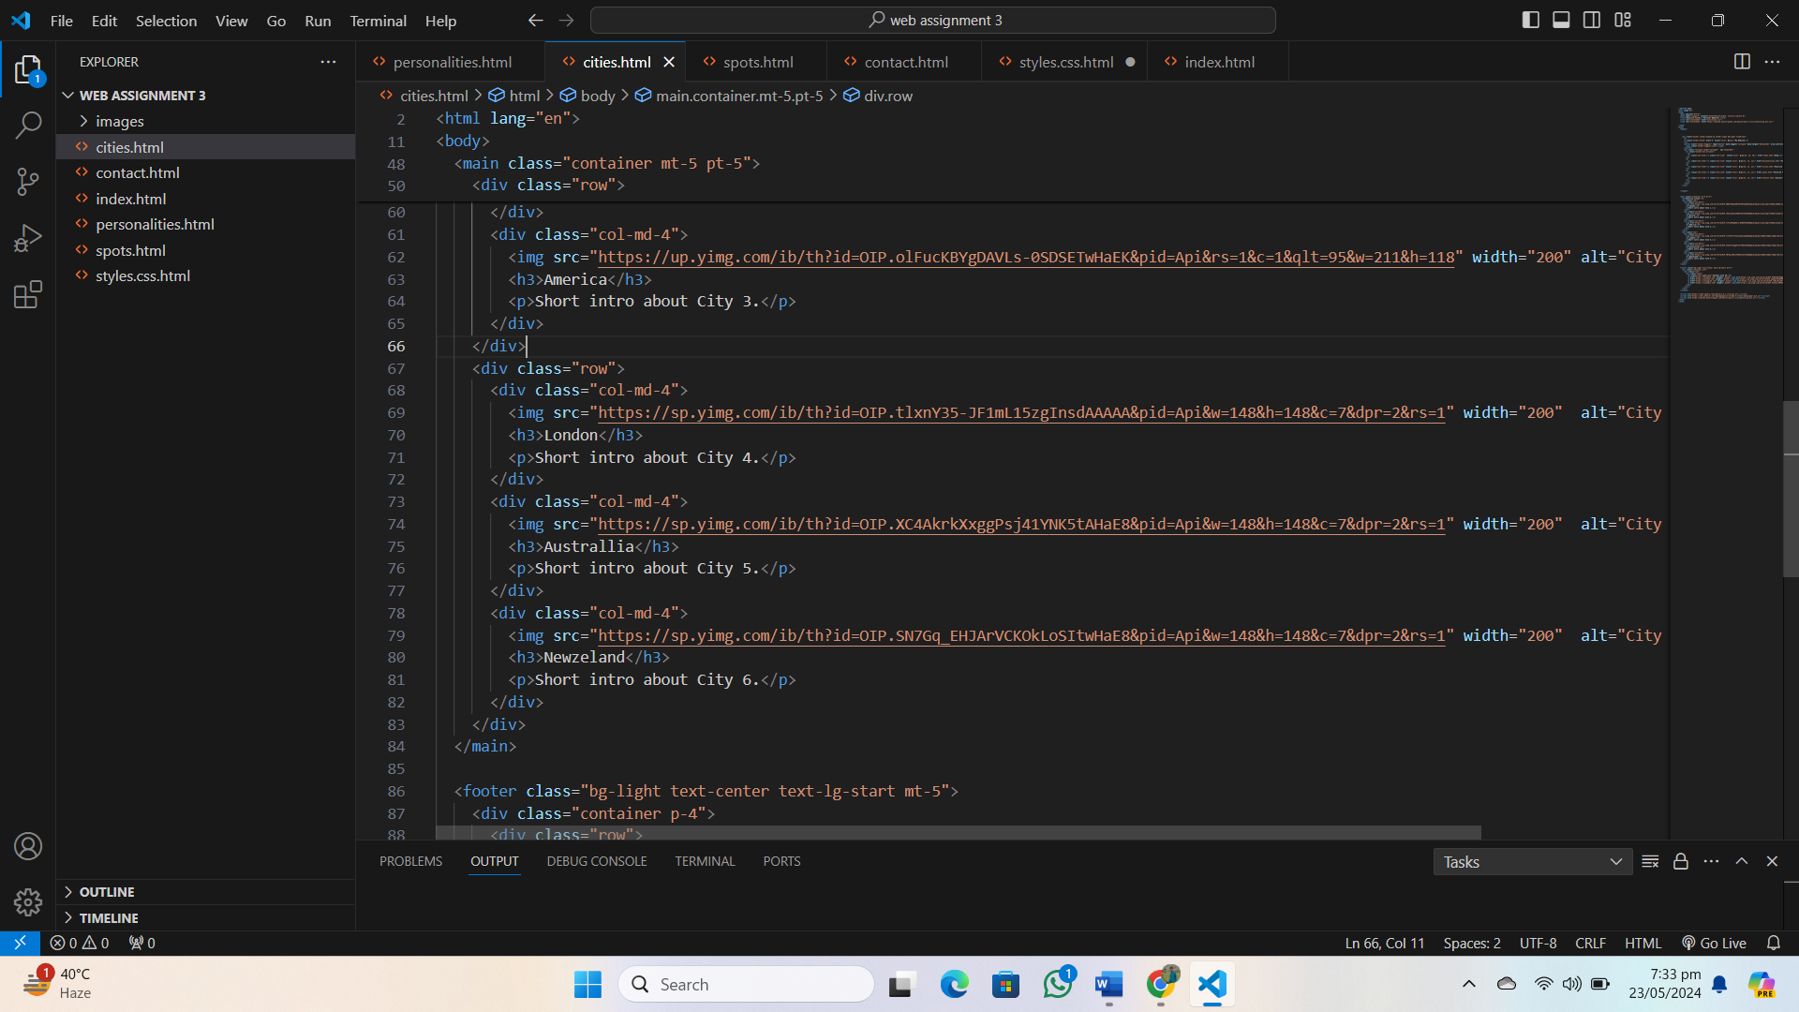

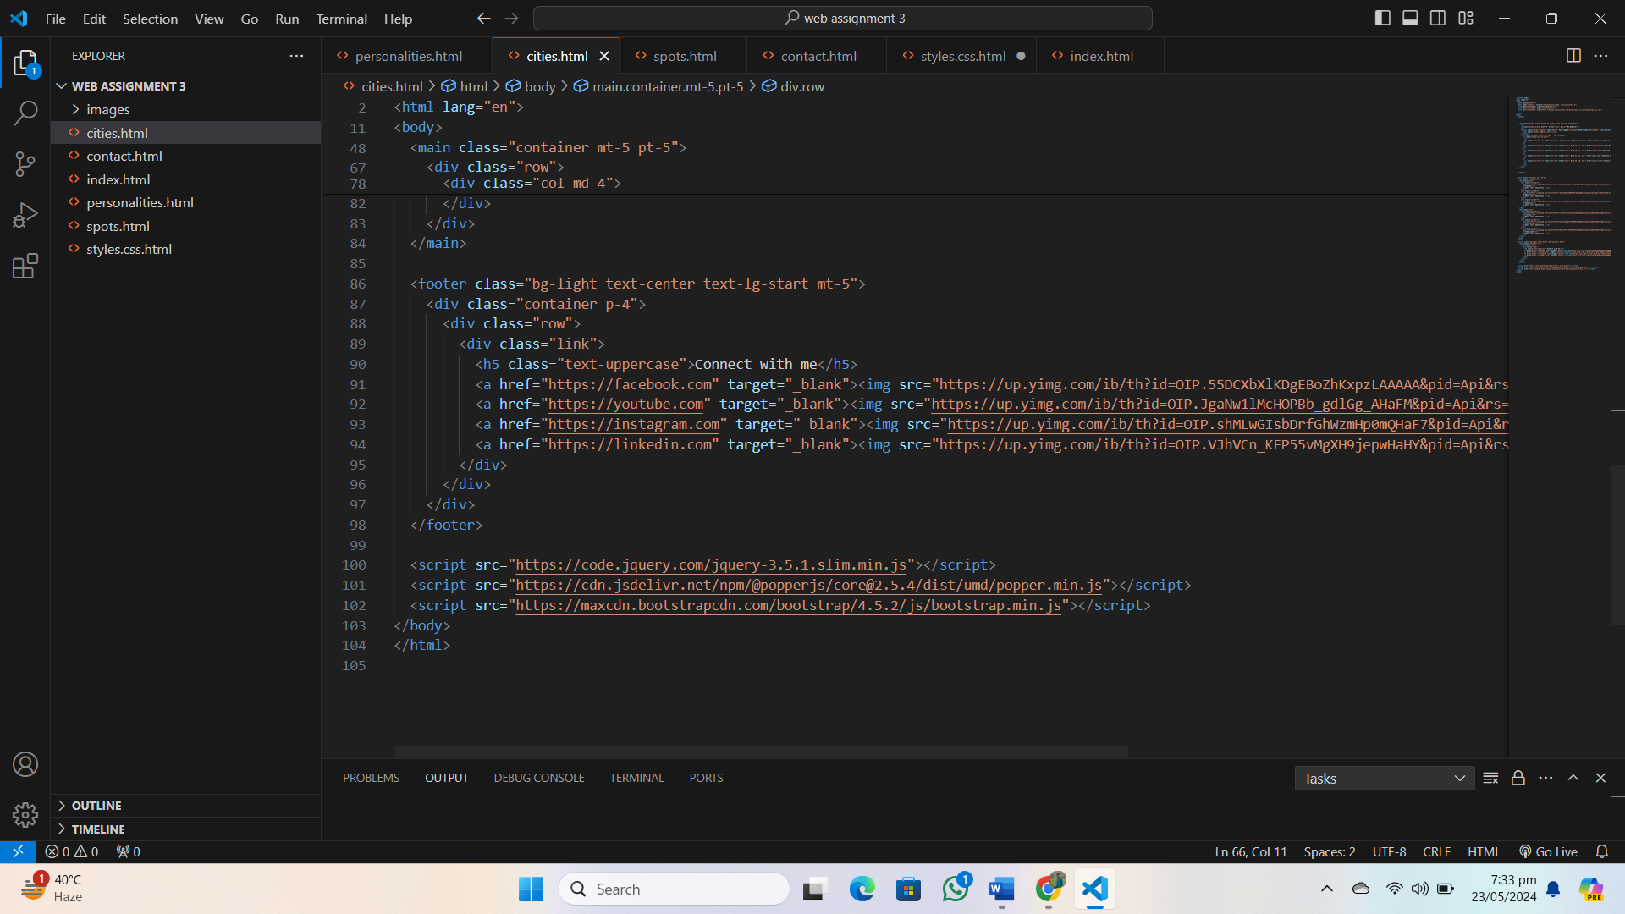

* **Contact.html :**

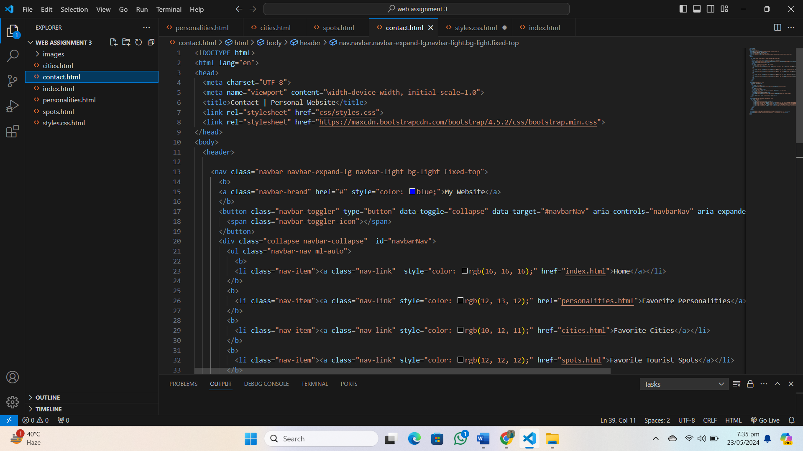

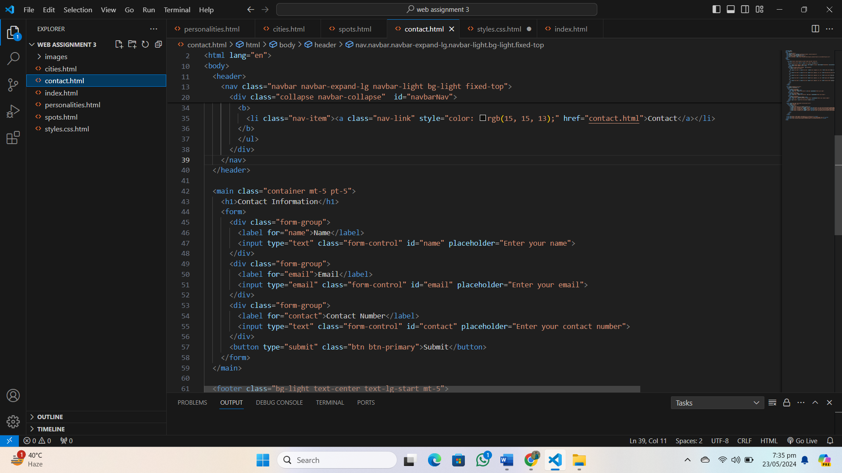

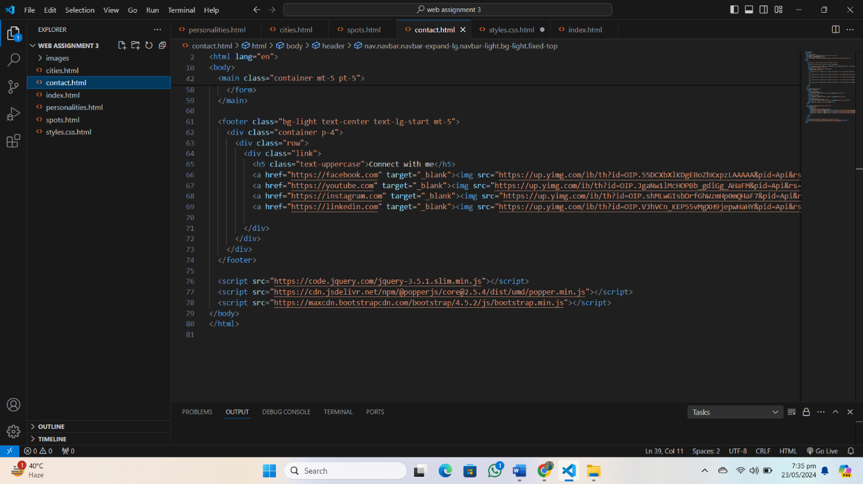

* **Personalities.html :**

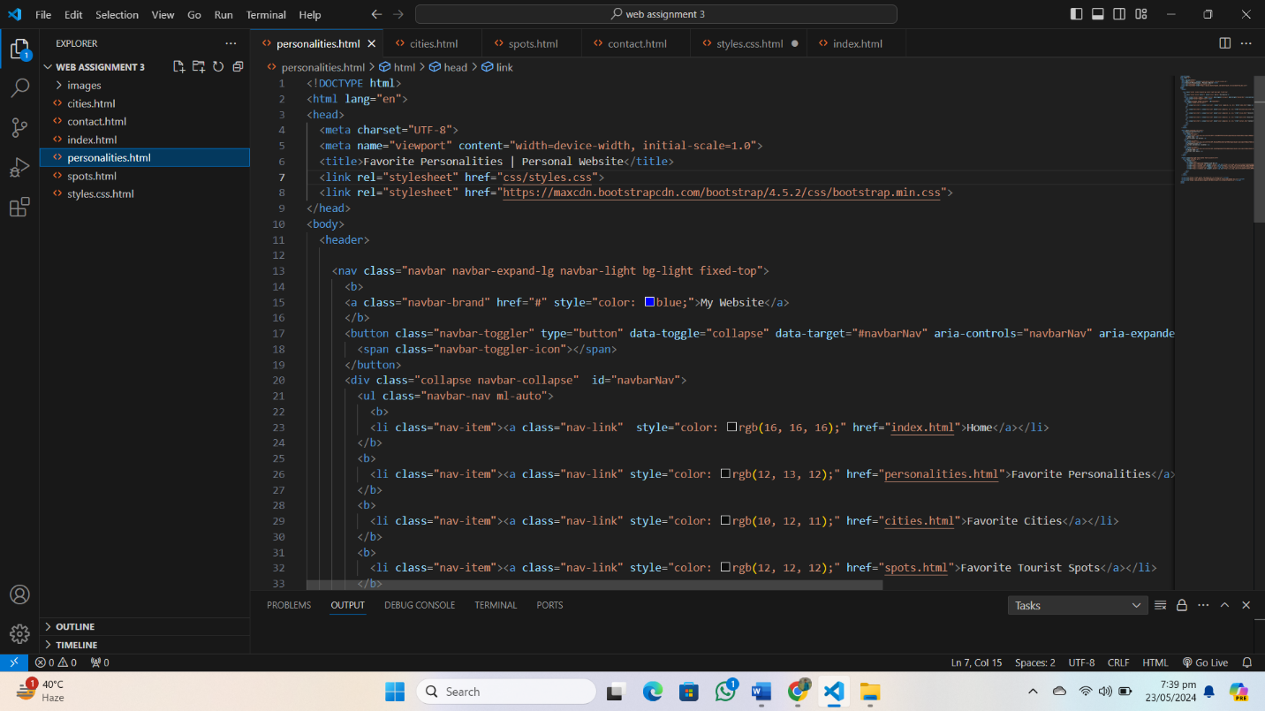

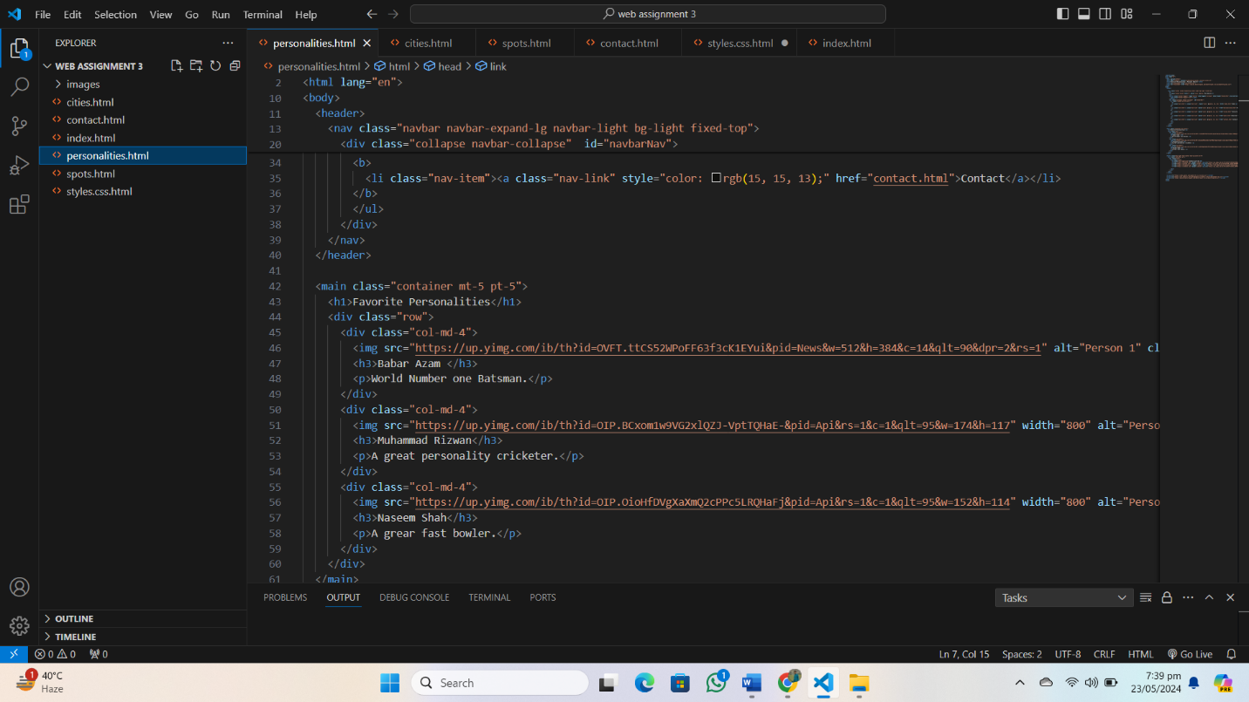

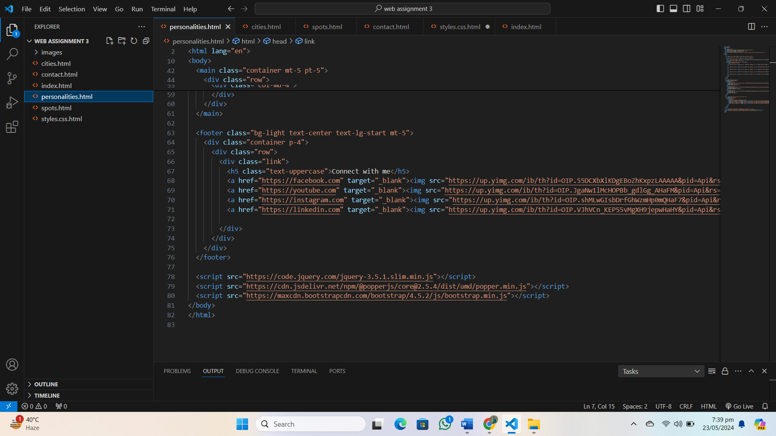

* **Spots.html :**

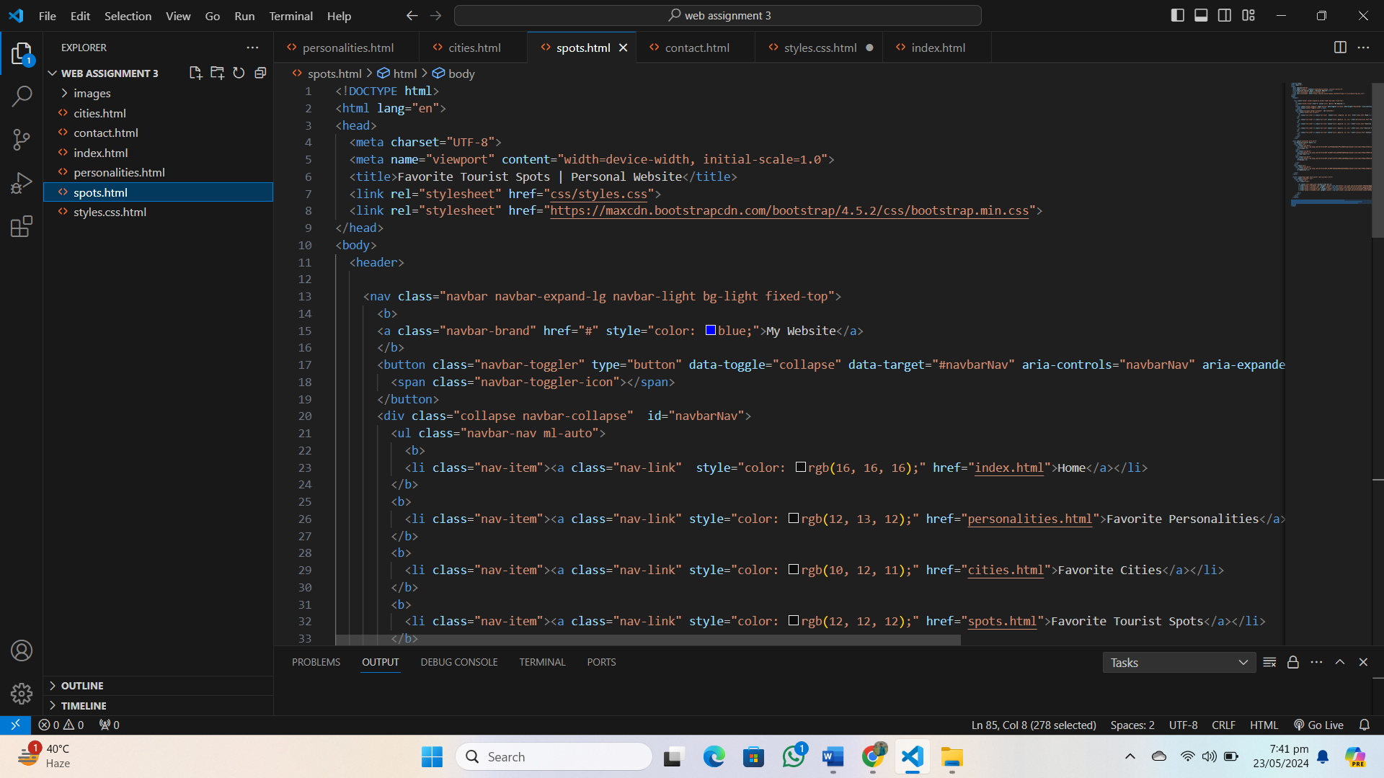

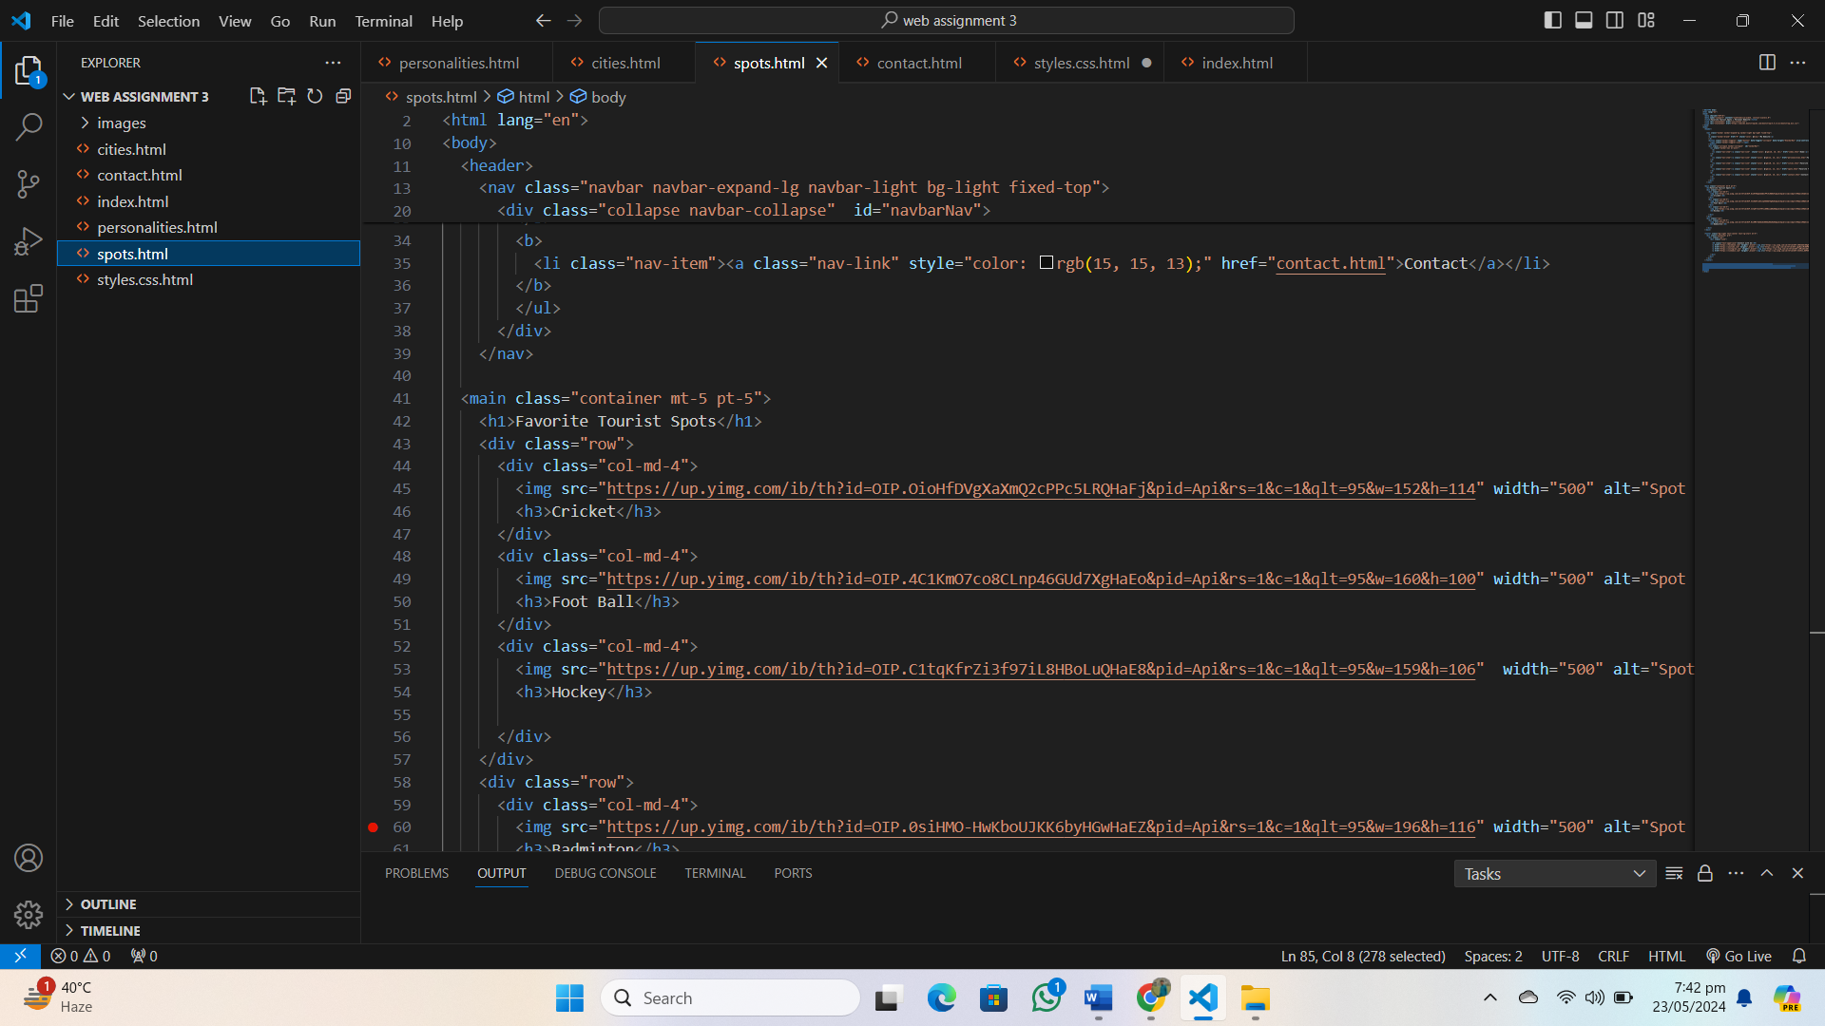

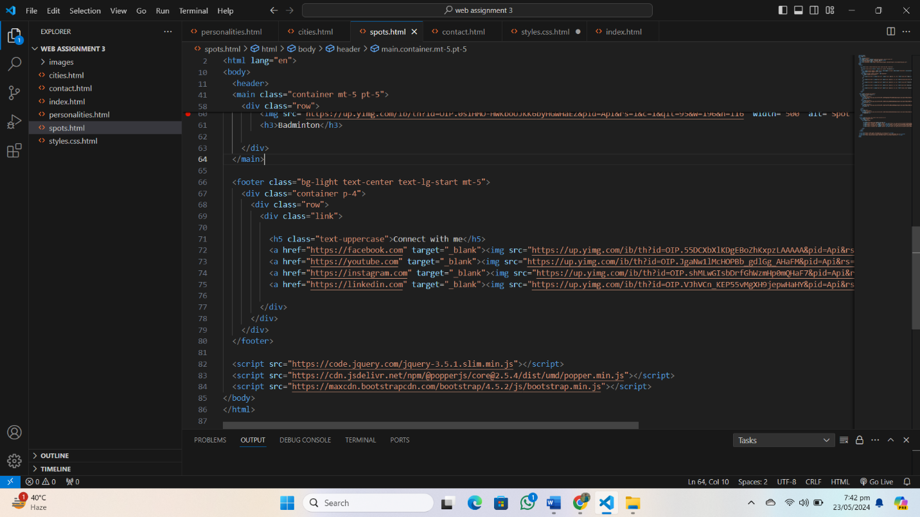

* **Styles.css.html :**

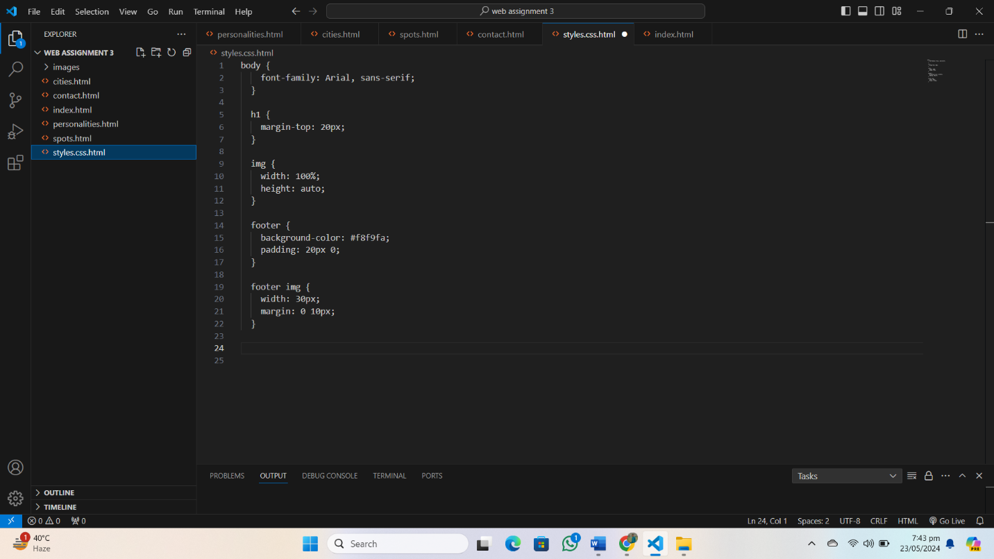

**Website Pages Pictures :**

* **Home page :**

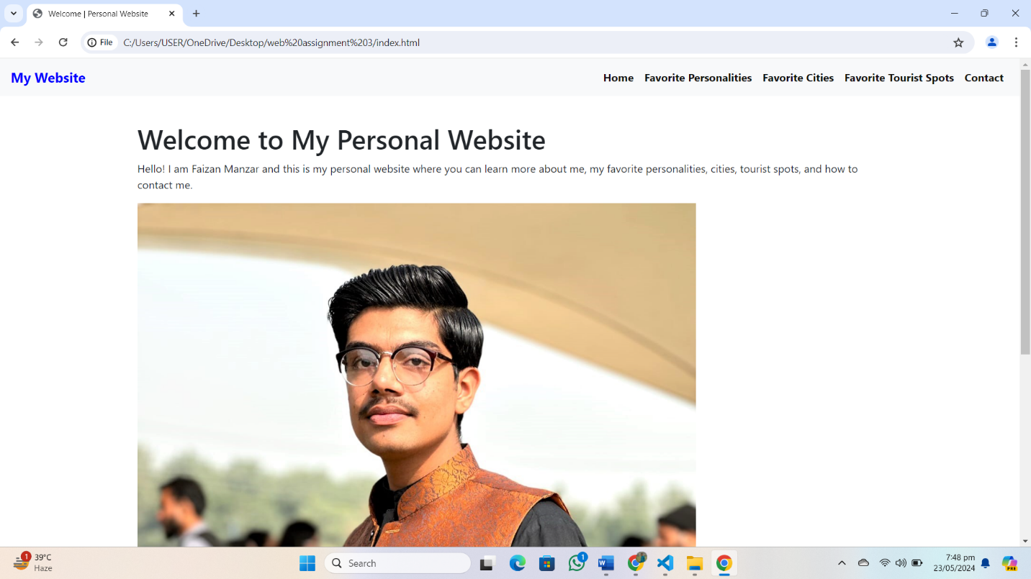

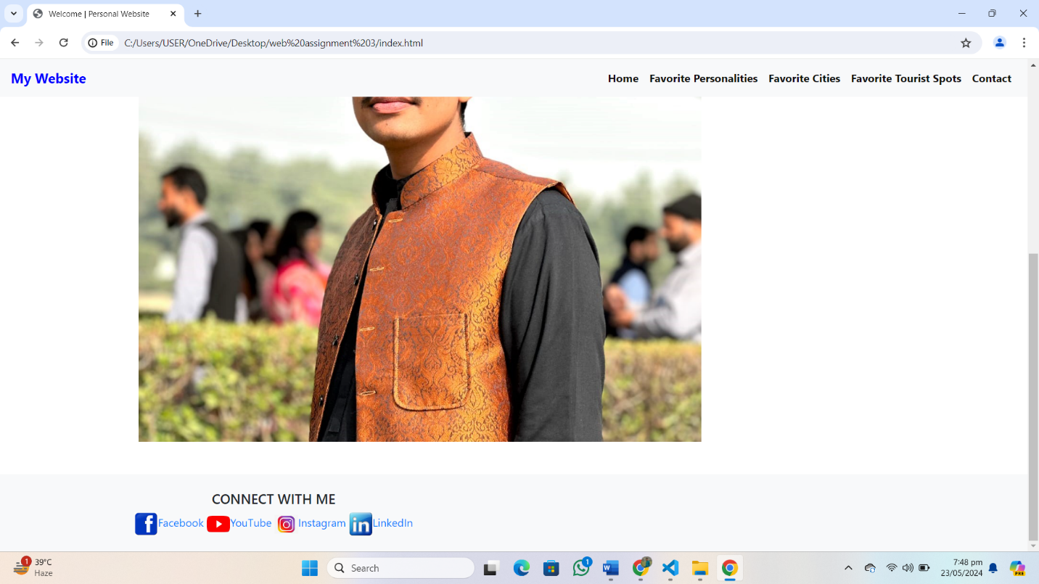

* **Favorite Personalities page :**

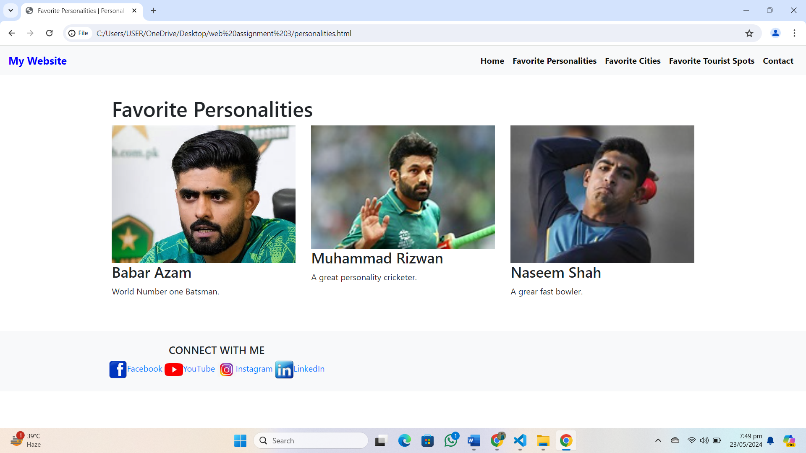

# Favorite Cities page :

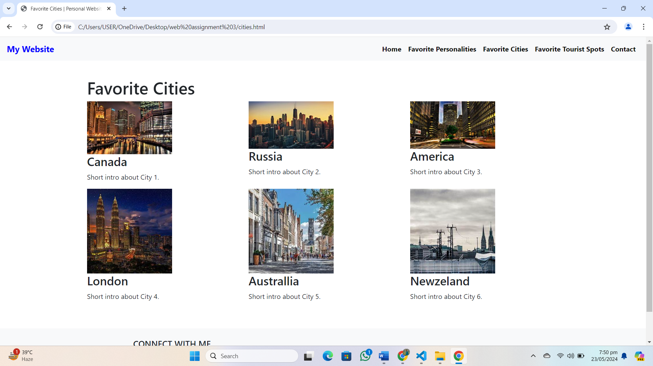

# Favorite Tourist Spots page :

# 

# Contact Information page :

# 